Amannisa

LEGAL TEAM
Legal Support You Can Trust
Our legal team guides survivors through reporting, rights and next steps with care, confidentiality and respect.
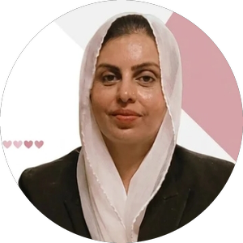  Rabia Samo  Advocate  15+ years of experience handling harassment cases. |  | 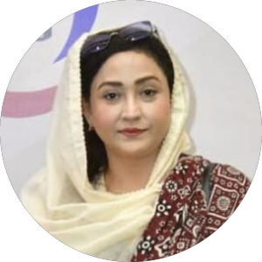  Afsheen Naz Bhutto  Advocate  15+ years of experience handling harassment cases.
Amannisa provides legal guidance and support. Every report is handled confidentially.
TEAM MEMBERS
The People Behind Amannisa
Dedicated members who volunteer their time, skills and heart to make women safer.
  Paras Bhutto  Team Member  Official Amannisa Society member |  | 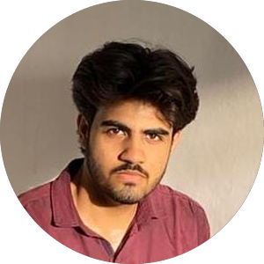  Huzaifa Junejo  Team Member  Official Amannisa Society member |  |   Umar Qureshi  Team Member  Official Amannisa Society member
  Syed Younis Shah  Team Member  Official Amannisa Society member |  |   Aina Syed  Team Member  Official Amannisa Society member

COLLABORATORS
Our Partners & Collaborators
Organizations that support Amannisa's mission.
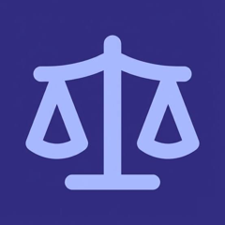  Draftify  Collaborator |  |   WomenWheelz  Collaborator |  | 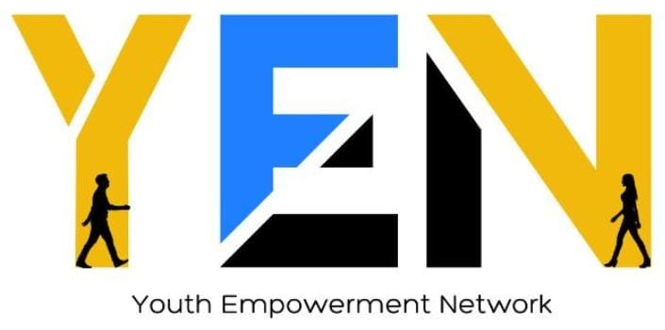  YEN  Collaborator

